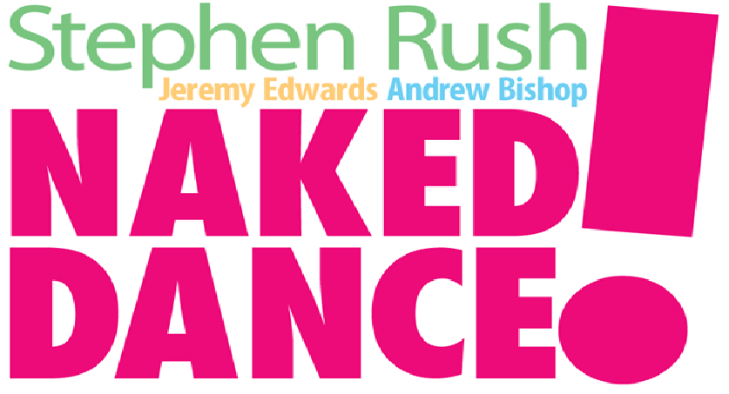
COMING TO GRAND RAPIDS!!

FRIDAY, FEBRUARY 25 / 8 P.M.

AT

MEXICAINS SANS FRONTIERES

http://hugo-claudin.blogspot.com/

120 SOUTH DIVISION /Grand Rapids

$5.00 ADMISSION
APPROPRIATE FOR ALL AGES

Naked Dance: Stephen Rush, Andrew Bishop and Jeremy Edwards

Originally from Grand Rapids, Composer-pianist Rush, drummer Edwards are joined by clarinetist-flutist Andrew Bishop in a performance to celebrate the release of their new album Naked Dance!, a collection that features original compositions reminiscent of Jimmy Guiffre and Jan Garbarek. Comic artist Jef Mallett, creator of the Frazz comic strip, created the strip featured on the cover of the album - which is both vinyl and digital, and will be for sale at this special concert in Rush's home town.

Stephen Rush
Stephen is a Full Professor at the University of Michigan, where he has worked with students from music, dance, art, and engineering, teaching Creative Process and directing the Digital Music Ensemble - for the last 25 years. With DME he has premiered works by Glass, La Monte Young and John Cage, as well as recording with Pauline Oliveros and “Blue Gene” Tyranny.
Rush has had premieres in five continents, many publications, and a book on Jazz theology called “Better Get It In Your Soul”. He has written 5 operas, 100’s of work for Dance, chamber and electronic works, concertos, and two symphonies, performed in by the Detroit Symphony and the Warsaw National Symphony.
There are over 25 CDs of Rush’s classical and jazz compositions released worldwide, and he has performed with Roscoe Mitchell, Henry Grimes, Steve Swell, Eugene Chadbourne, his band "Yuganaut", and the late Peter Kowald. He also tours and records with his “techno band”, Listening Music from the Age of the Crystal Moon Cone with Chris Peck and Jon Moniaci.

Jeremy Edwards
Jeremy Edwards is a drummer/percussionist, recording engineer, composer and educator working in a variety of musical genres. He received a bachelors degree in music technology and percussion and a masters degree in improvisation from the University of Michigan. Jeremy has actively toured the United States and Canada performing original music and continues to perform locally with rock, jazz and experimental music groups. Jeremy works for the University of Michigan School of Music, Theatre and Dance as a music and multimedia computer specialist.

Andrew Bishop
Andrew Bishop is a composer and improviser in highly diversified musical idioms. As a composer he has received over 20 commissions from professional organizations and universities, numerous residencies, and recognition and awards from ASCAP, The Chicago Symphony Orchestra, the Andrew W. Melon Foundation, and a nomination from the American Academy of Arts and Letters. He leads a variety of his own ensembles and his two recordings as a leaderTime and Imaginary Time and the Hank Williams Project (both on Envoi Recordings) received high praise from the New York Times, Downbeat, and All About Jazz, among others. He has performed with Karl Berger, Sandip Burman, Kenny Burrell, Eugene Chadbourne, Ray Charles, Gerald Cleaver, Drew Gress, Jerry Hahn, Chris Lightcap, Mat Maneri, Tony Malaby, Hank Roberts, Jacob Sacks, Craig Taborn, Clark Terry, Matt Wilson, and John Zorn among others.

For further information please contact: Hugo Claudin at tlaquachito@hotmail.com
or Stephen Rush at srush@umich.edu

